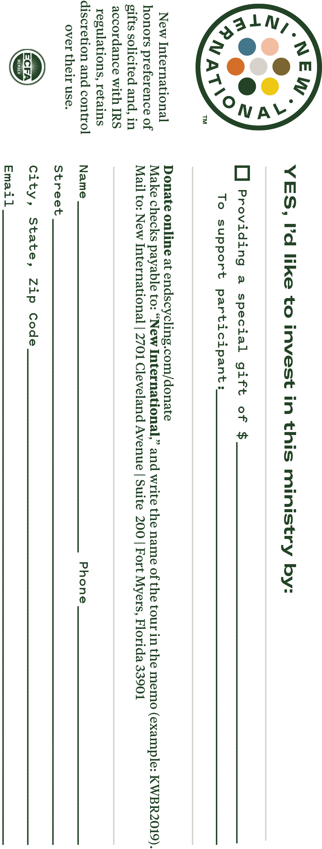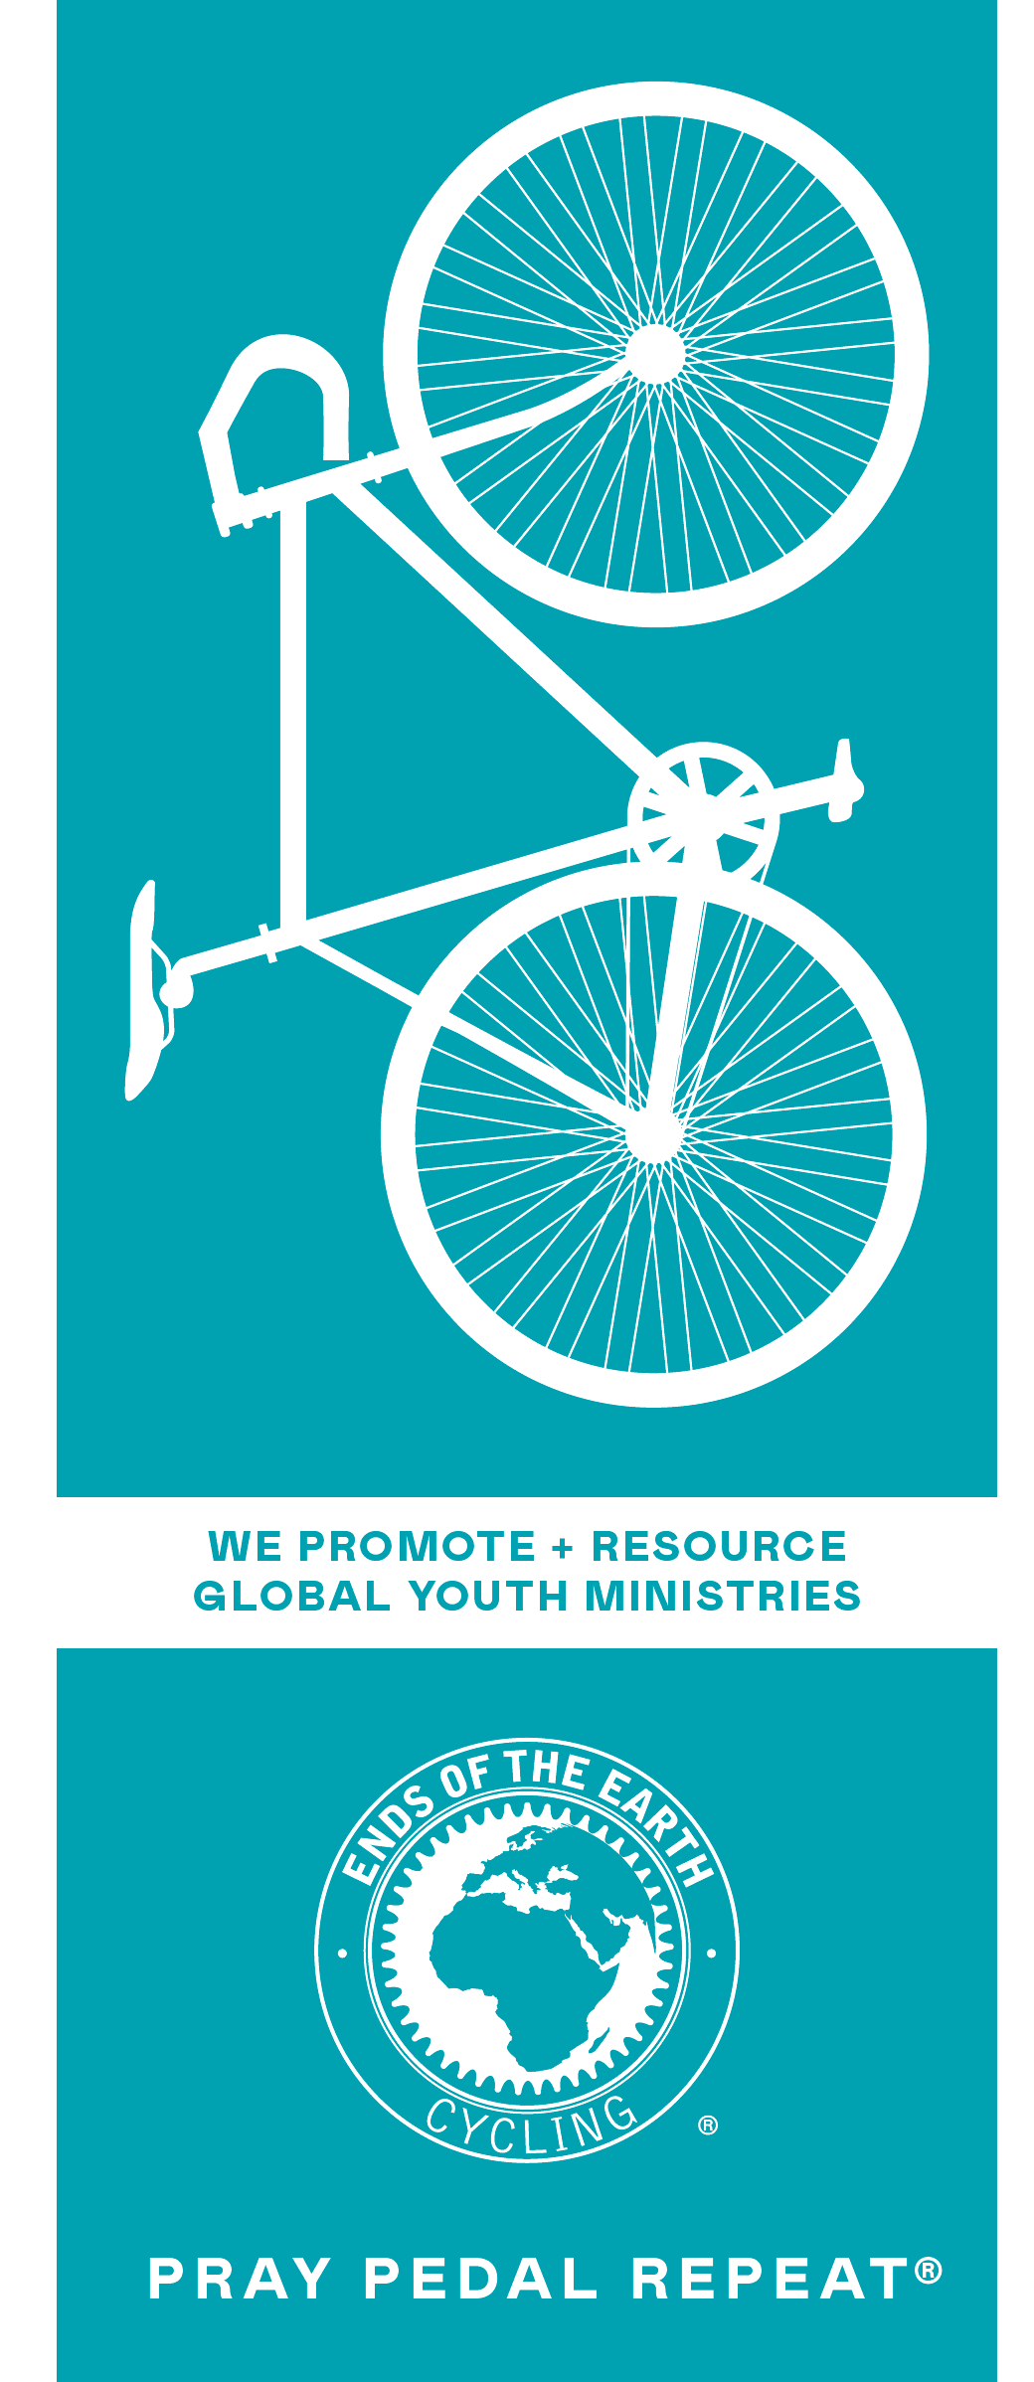 ­­­­­

**Customizable Area #3**

**INSTRUCTIONS:**

Please use this flier outline as a tool to help you raise your pledge. Anything in **RED** requires your attention and should be changed or removed before printing. Feel free to make this flier your own (**keeping pics the same**).

**Directions for Printing:**

1. Customize the 3 areas (Including this one) to desired content.
2. Adjust your font size – Make all your words fit into ALL THREE PANES. Size 14 font is suggested. It is not recommended to use a font size smaller than 11.
3. Select “***Print On Both Sides – Flip Pages On Short Edge***” or select “**Two-Sided Printing**” and select, “***Short Edge Printing****.*” to print properly.
4. Print in color for best results.
5. Fold as a Tri-Fold Brochure.

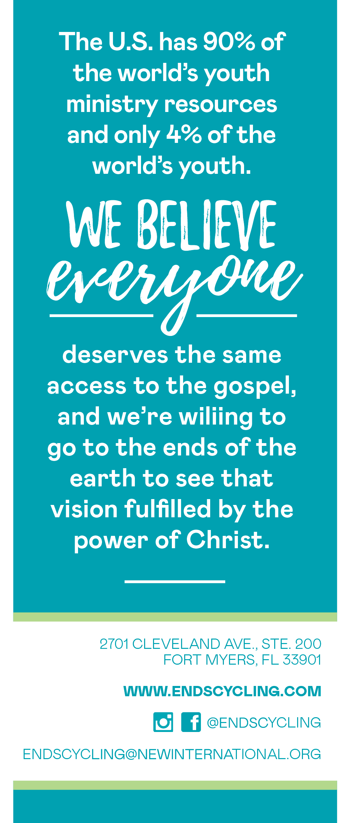

**Customizable Area #2**

I have a fundraising pledge of $1,000, so that __COPY / PASTE CONTENT, BEING EVEN MORE SELECTIVE (SHORTER) OF INFO FROM YOUR TOUR INFORMATION PAGE ABOUT THE **MINISTRY YOU ARE RIDING FOR –** EXAMPLE: “MINISTRY LEADERS CAN BE TRAINED TO REACH THE LOST FOR JESUS CHRIST IN KENYA, AFRICA.”__

Would you pray for me as I train and for my family, we are in this together? Would you consider a gift of $50, $100 or even $500 for this cause?

After the ride is complete, I will be sharing testimonies with you. Thank you for your friendship and for taking the time to consider my request. You can find out more information at EndsCycling.com. You can donate securely online at **EndsCycling.com/donate** or by check (info on the back).

More room on “Customizable Area 3”

**Customizable Area #1**

Hello Friends!

I, __NAME__ , am about to embark on a long journey - _INSERT # OF MILES_ - miles to be exact! You may think: What’s the big deal? My plan however, is not to drive, but rather PEDAL! In __TOUR MONTH & YEAR__ I plan on joining dozens of other believers on the __TOUR NAME__ .

This bicycle ride is being put on by Ends of the Earth Cycling (a ministry of New International). New International has been in ministry for over 30 years and have 200+ missionaries in over 40 countries.

I have decided to ride because __INSERT **COUNTRY & REASON FOR RIDING** OR COPY / PAST SELECT INFO **FROM THE TOURS INFORMATION PAGE** (FIND THEM AT EndsCycling.com/tours – click on your tour) ABOUT THE MINISTRY YOU ARE RIDING FOR__